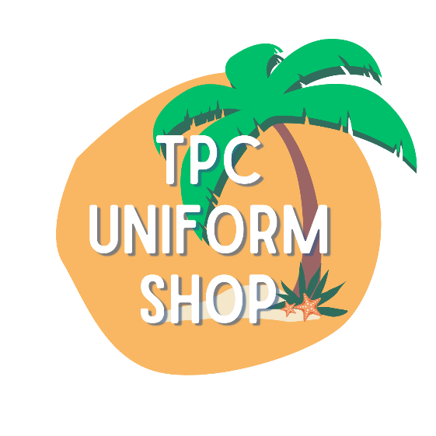
2023 PRICE LIST

STANDARD UNIFORM ITEMS
TPC Shorts (sizes 2 to 20) $28.00
TPC Skorts (sizes 2 to 20) $28.00
TPC Polo Shirt (sizes 2 to 20) $35.00
TPC Stretchy Skirt (sizes 4 to 16) $38.00
TPC Dress (sizes 4 – 16) $55.00

HATS
Optional Toggle & Tie $3.00
Prep Band (to attach to a plain hat) $4.00
Plain Broad Brim Hat (sizes S/M/L/XL) $13.00
TPC Broad Brim Hat with Toggle & Tie (sizes S/M/L) $36.00
TPC Prep Hat with Band & Toggle & Tie (sizes S/M/L) $40.00

ACCESSORIES
Hair Scrunchie (to match the dress) $5.00
Korker Hair Tie or Clip $5.00
Curly Korker Hair Tie $5.50
Ribbon Headband $6.00
TPC Bamboo Socks (single pack) $6.50
Library Bags (year 1 to year 6) $12.00
TPC Bamboo socks (pack of 3) $16.50
Raincoat – covers backpack (sizes 4-7 / 8-12) $28.00
TPC Backpack (7 year warranty) $59.00

WINTER
TPC V-Neck Fleece Jumper (sizes 4 – 16) $48.00
TPC Zip-Up Jacket (sizes 4 – 18) $58.00

SPORTS
House Colours Curly Korker Hair Tie $5.50
Swimming Cap (Stradbroke / Moreton / Fraser / Bribie) $10.00
TPC Swimming Bag $18.00
House Polos (Stradbroke / Moreton / Fraser/Bribie) $22.00

